Chapter11 I/O Management and Disk Scheduling
Answers to Questions

11.1 Programmed I/O: The processor issues an I/O command, on behalf of a process, to an I/O module; that process then busy-waits for the operation to be completed before proceeding. Interrupt-driven I/O: The processor issues an I/O command on behalf of a process, continues to execute subsequent instructions, and is interrupted by the I/O module when the latter has completed its work. The subsequent instructions may be in the same process, if it is not necessary for that process to wait for the completion of the I/O. Otherwise, the process is suspended pending the interrupt and other work is performed. Direct memory access (DMA): A DMA module controls the exchange of data between main memory and an I/O module. The processor sends a request for the transfer of a block of data to the DMA module and is interrupted only after the entire block has been transferred.

11.2 Logical I/O: The logical I/O module deals with the device as a logical resource and is not concerned with the details of actually controlling the device. The logical I/O module is concerned with managing general I/O functions on behalf of user processes, allowing them to deal with the device in terms of a device identifier and simple commands such as open, close, read, write. Device I/O: The requested operations and data (buffered characters, records, etc.) are converted into appropriate sequences of I/O instructions, channel commands, and controller orders. Buffering techniques may be used to improve utilization.

11.3 Block-oriented devices stores information in blocks that are usually of fixed size, and transfers are made one block at a time. Generally, it is possible to reference data by its block number. Disks and tapes are examples of block-oriented devices. Stream-oriented devices transfer data in and out as a stream of bytes, with no block structure. Terminals, printers, communications ports, mouse and other pointing devices, and most other devices that are not secondary storage are stream oriented.

11.4 Double buffering allows two operations to proceed in parallel rather than in sequence. Specifically, a process can transfer data to (or from) one buffer while the operating system empties (or fills) the other.

11.5 Seek time, rotational delay, access time.

11.6 FIFO: Items are processed from the queue in sequential first-come-first-served order.. SSTF: Select the disk I/O request that requires the least movement of the disk arm from its current position. SCAN: The disk arm moves in one direction only, satisfying all outstanding requests en route, until it reaches the last track in that direction or until there are no more requests in that direction. The service direction is then reversed and the scan proceeds in the opposite direction, again picking up all requests in order. C-SCAN: Similar to SCAN, but restricts scanning to one direction only. Thus, when the last track has been visited in one direction, the arm is returned to the opposite end of the disk and the scan begins again.

11.7 0: Non-redundant 1: Mirrored; every disk has a mirror disk containing the same data. 2: Redundant via Hamming code; an error-correcting code is calculated across corresponding bits on each data disk, and the bits of the code are stored in the corresponding bit positions on multiple parity disks. 3: Bit-interleaved parity; similar to level 2 but instead of an error-correcting code, a simple parity bit is computed for the set of individual bits in the same position on all of the data disks. 4: Block-interleaved parity; a bit-by-bit parity strip is calculated across corresponding strips on each data disk, and the parity bits are stored in the corresponding strip on the parity disk. 5: Block-interleaved distributed parity; similar to level 4 but distributes the parity strips across all disks. 6: Block-interleaved dual distributed parity; two different parity calculations are carried out and stored in separate blocks on different disks.

11.8 512 bytes.

Answers to Problems
11.1 If the calculation time exactly equals the I/O time (which is the most favorable situation), both the processor and the peripheral device running simultaneously will take half as long as if they ran separately. Formally, let C be the calculation time for the entire program and let T be the total I/O time required. Then the best possible running time with buffering is max(C, T), while the running time without buffering is C + T; and of course ((C + T)/2) ≤ max(C, T) ≤ (C + T). Source: [KNUT97].

11.2 The best ratio is (n + 1):n. Source: [KNUT97].

11.3 Disk head is initially moving in the direction of decreasing track number:

FIFO |  | SSTF |  | SCAN |  | C-SCAN
Next track accessed | Number of tracks traversed | Next track accessed | Number of tracks traversed | Next track accessed | Number of tracks traversed | Next track accessed | Number of tracks traversed
27 | 73 | 110 | 10 | 64 | 36 | 64 | 36
129 | 102 | 120 | 10 | 41 | 23 | 41 | 23
110 | 19 | 129 | 9 | 27 | 14 | 27 | 14
186 | 76 | 147 | 18 | 10 | 17 | 10 | 17
147 | 39 | 186 | 39 | 110 | 100 | 186 | 176
41 | 106 | 64 | 122 | 120 | 10 | 147 | 39
10 | 31 | 41 | 23 | 129 | 9 | 129 | 18
64 | 54 | 27 | 14 | 147 | 18 | 120 | 9
120 | 56 | 10 | 17 | 186 | 39 | 110 | 10
Average | 61.8 | Average | 29.1 | Average | 29.6 | Average | 38

If the disk head is initially moving in the direction of increasing track number, only the SCAN and C-SCAN results change:
SCAN |  | C-SCAN
Next track accessed | Number of tracks traversed | Next track accessed | Number of tracks traversed
110 | 10 | 110 | 10
120 | 10 | 120 | 10
129 | 9 | 129 | 9
147 | 18 | 147 | 18
186 | 39 | 186 | 39
64 | 122 | 10 | 176
41 | 23 | 27 | 17
27 | 14 | 41 | 14
10 | 17 | 64 | 23
Average | 29.1 | Average | 35.1

11.4 It will be useful to keep the following representation of the N tracks of a disk in mind:
0 | 1 | • • • | j – 1 | • • • | N – j | • • • | N – 2 | N – 1
a. Let us use the notation Ps [j/t] = Pr [seek of length j when head is currently positioned over track t]. Recognize that each of the N tracks is equally likely to be requested. Therefore the unconditional probability of selecting any particular track is 1/N. We can then state:
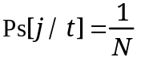 if t ≤ j – 1 OR t ≥ N – j
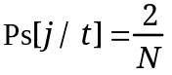 if j – 1 < t < N – j
In the former case, the current track is so close to one end of the disk (track 0 or track N – 1) that only one track is exactly j tracks away. In the second case, there are two tracks that are exactly j tracks away from track t, and therefore the probability of a seek of length j is the probability that either of these two tracks is selected, which is just 2/N.

b. Let Ps [K] = Pr [seek of length K, independent of current track position]. Then:

From part (a), we know that Ps[K/t] takes on the value 1/N for 2K of the tracks, and the value 2/N for (N – 2K) of the tracks. So

c.
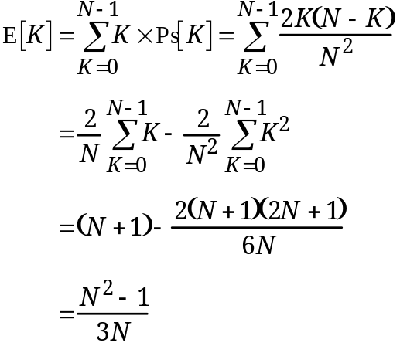

d. This follows directly from the last equation.

11.5 Define
Ai = Time to retrieve a word from memory level i
Hi = Probability that a word is in memory level i and no higher-level memory
Bi = Time to transfer a block of data from memory level (i + 1) to memory level i
Let cache be memory level 1; main memory, memory level 2, and so on, for a total of N levels of memory. Then, we can write
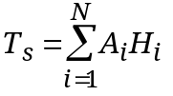
Now, recognize that if a word is in M1 (cache), it is read immediately. If it is in M2 but not in M1, then a block of data is transferred from M2 to M1 and then read. Thus
A2 = B1 + A1
Further
A3 = B2 + A2 = B1 + B2 + A1
Generalizing,
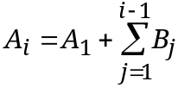
So
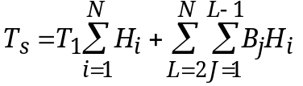
But 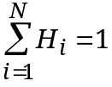
Finally
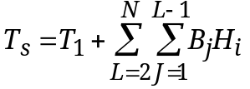

11.6 a. The middle section in Figure 11.11b is empty. Thus, this reduces to the strategy of Figure 11.11a.
b. The old section consists of one block, and we have the LRU replacement policy.

11.7 The density can be expressed as 1600 characters per inch. Therefore the transfer rate is 1600 × 120 = 192,000 characters per second.

11.8 We provide the answers for 30 blocks per record.
b. First, let us determine how long it takes to read one physical block plus the gap to the next block.
Size of physical block = (30 logical records per physical record) × (120 bytes per logical record) = 3600 bytes
Length of physical block = 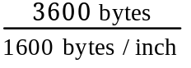 = 2.35 in
Length of gap = 0.6 in
Transfer time for one block plus gap = 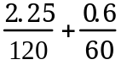 = 0.02875 seconds
The number of blocks on the tape can be computed as
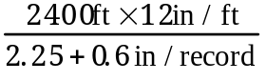 = 10,105 physical blocks
Thus, the time to read a full tape is 10,105 × 0.02875 = 291 seconds

c. With a blocking factor of 30, the tape holds 10,105 physical records and 30 × 10,105 = 303,150 logical records.
d. The effective transfer rate, with a blocking factor of 30:
R = 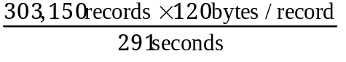 = 125,010 bytes/second

e. Capacity = 303,150 records × 120 bytes/record = 36,378,000 bytes

11.9 Each sector can hold 4 records. The required number of sectors is 303,150/4 = 75,788 sectors. This requires 75,788/96 = 790 tracks, which in turn requires 790/110 = 8 surfaces.

11.10 There are 512 bytes/sector. Since each byte generates an interrupt, there are 512 interrupts. Total interrupt processing time = 2.5 × 512 = 1280 µs. The time to read one sector is:
((60 sec/min) / (360 rev/min)) / (96 sectors/track)
= 0.001736 sec = 1736 µs
Percentage of time processor spends handling I/O:
(100) × (1280/1736) = 74%

11.11 With DMA, there is only one interrupt of 2.5 µs. Therefore, the percentage of time the processor spends handling I/O is
(100) × (2.5/1736) = 0.14%

11.12 Only one device at a time can be serviced on a selector channel. Thus,
Maximum rate = 800 + 800 + 2 × 6.6 + 2 × 1.2 + 10 × 1 = 1625.6 KBytes/sec

11.13 It depends on the nature of the I/O request pattern. On one extreme, if only a single process is doing I/O and is only doing one large I/O at a time, then disk striping improves performance. If there are many processes making many small I/O requests, then a nonstriped array of disks should give comparable performance to RAID 0.

